Preview of entity safety checks before normalization:

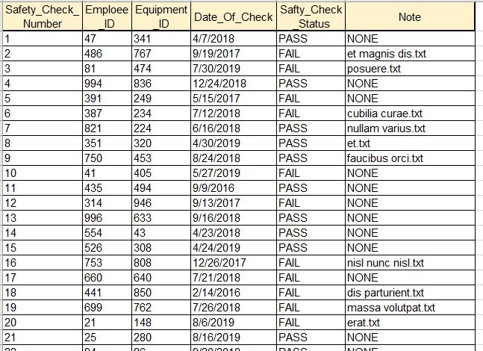

1NF

All value is atomic. There is no NULL values or repeating groups.

2NF

PK is safety_check_number.

FK are employee_ID and equipment_ID.

All dependency is on PK.

3NF

There is no transitive dependency.

Preview of table after normalization:

